Course Work Project Description and Rubric
Semester | 202510 |  | Division |  | CIS
Assessment title in Syllabus | Project |  | Program |  | IT and IS
1
Course Code | CDS 2413
Course Title | Programming for Data Science
CLOs | All CLOs |  | Accreditation Body |  | CAA & CIPS
Course Instructor |  |  | CRN
Assessment Weight | 40% |  | Submission Date |  | Week 14
For Group Work submissions an additional individual assessment will be conducted.
Grades for the students in one group will vary based on the individual performance in the additional assessment.
Student Declaration:
Academic Integrity Statement
In accordance with the HCT Academic Integrity Policy
• Students are required to refrain from all forms of academic integrity breaches as defined and explained by HCT.
• A student found guilty of having committed acts of academic integrity breach(es) will be subject to the relevant sanctions as outlined by HCT.
إفادة النزاهة الأكاديمية
وفقًا لسياسة كليات التقنية العليا للنزاهة الأكاديمية
• على الطلبة الإلتزام بلوائح وقواعد النزاهة الأكاديمية، كما هو مبيّن وموضح في السياسات والإجراءات الخاصة بكليات التقنية العليا.
• في حالة ارتكاب الطالب أي شكل من أشكال الإخلال بالنزاهة الأكاديمية، سيتعرض الى العقوبات الموضحة في السياسات ذات الصلة.
This assignment is entirely my own work except where I have duly acknowledged other sources in the text and listed those sources at the end of the assignment. I have not previously submitted this work to the HCT, or any other entity. I understand that I may be orally examined on my submission.
Student (s) Signature: ___________________________________
___________________________________________

Student Name(s): | Rowdha Anwar | Jawhra Saeed
Student HCT ID(s): | H00492189 | H00492192 |  | H00

For Examiner’s Use Only
 | Group (50%) |  |  |  |  | Individual (50%)
CLO | 1 | 2 | 3 | 4 | Report Formatting | Oral Defense | Anaconda Certificate | Total | %
Marks Allocated | 10 | 10 | 42 | 26 | 12 | 40 | 10 | 100 | 40
Marks Obtained

Project Objectives
This is an intensive project-based course. It enables students to perform data analysis using Python programming. Students should select their dataset from a free source and conduct a methodical data analysis using Machine Learning algorithms. The project's primary objectives are:
- Generate a data summary using descriptive analysis
- Create a sample and visualize sample data using graphs/charts and remove the unwanted outliers;
- Investigate the correlation between the variables;
- Perform hypothesis testing if you have any assumptions about your dataset;
- Perform data preprocessing prior to building a data model;
- Create and optimize the regression model for the selected dataset in order to predict the values; and
- Develop and Optimize the classification model for the selected dataset in order to predict the values.
- Analyze the data for patterns or groups based on clustering and optimize the model in order to obtain the desired output.
- Consolidate learning through the Anaconda Python for Data Science certification and reflect critically on your data science journey, connecting conceptual knowledge with applied project work.

Project Description
You are assigned to work on the data analysis for chosen dataset. The list of datasets is available in a Kaggle data source(https://www.kaggle.com/datasets). The project carries 40% of your coursework marks. You are required to work in a team of maximum TWO (2) members. It is important that you need to collaborate in working on the project within your team. The collaboration between the team members will be recorded, tracked, and monitored.
For CLO1, CLO2, and CLO3 – Regression, same dataset should be used
If required, then CLO3 – classification and Cluster, different dataset can be used.
New Requirement (Individual Component - 10 Marks): Anaconda Python for Data Science Professional Certificate (via Coursera) Each student is expected to complete the Anaconda Python for Data Science Professional Certificate course on LinkedIn Learning and submit a screenshot of the completion certificate. The program includes multiple courses (e.g., Intro to Data Science, Statistics Foundations, Learning Python, Python Data Analysis) and students must complete and submit all.
Students are required to:
- Submit individual course completion certificates for each course in the certification path sequentially.
- Submit the final Professional Certificate
- Submit individual reflection summarizing your learning experience, key takeaways, and how the certification supported your understanding of the project work (this reflection is mandatory)
- Answer a viva question drawn from any of the covered course content during the individual oral defense.
- This component carries 10 marks under the individual evaluation rubric.

Project Tasks/Questions
CLO | Deliverable Learning Outcomes | Marks
1 | Define the purpose of data analysis for the chosen dataset | 2
1 | Identify and Justify the type of programming used for data analysis | 2
1 | Identify the type and purpose of the machine learning algorithm to be implemented for the chosen dataset | 3
1 | Identify and Justify the independent and dependent variables for the chosen dataset. | 3
1 | Will you do the sampling? Identify and justify the type of sampling to be used for the chosen dataset
1 | Total | 10
2 | - Justify why you want to perform the descriptive analysis for the chosen dataset. | 1
2 | - Create a script to develop a Python function for descriptive statistics. The input for the function should be the sample and the field to perform the descriptive statistics. | 1
2 | - Create a program to random sampling of size 150 and find the descriptive statistics for the dependent variable from the sample [Apply the descriptive function which you created]. | 1
2 | - Create a script for systematic sampling by giving certain conditions and finding the desc stat for the dependent variable from the sample [Apply the descriptive function which you created]. | 1
2 | - Create a detailed descriptive statistics report about the dependent variable of the chosen dataset. | 1
2 | - Visualize the dependent variable by the Graph/Chart of the following using Python Program:  - Scatter plot  - Box Plot  - Histogram  - Heat Map  Hint: Use Matplot or Ski-learn library | 3
2 | - Perform the hypothesis test to find the correlation (Pearson and Spearman for numerical variable and chi-square test for categorical variable) between the independent variable and the dependent variable.  Note: If you have more than one independent variable, then choose any one of the independent variables. | 1
2 | - Assess the performance of the dependent variable to know whether the sample is representative of the normal population by a one-sample t-test. | 1
2 | Total | 10
3 | - Build, Train, Develop and Evaluate using Simple Regression for chosen dataset. | 5
3 | - Develop a script to forecast the value of the dependent variable from all the relevant independent variables using Multiple Linear Regression | 5
3 | - Predict the value of the dependent variable from the different classifier such as Logistic Regression, KNN, Naïve-Bayes and Decision Tree. | 17
3 | - Evaluate the performance of each model using confusion matrix and accuracy and identify the best fit classifier for the chosen dataset. | 9
3 | - Predict the dependent variable by using best-fit classifier. | 1
3 | - Perform the cluster analysis such as K-means and Horizontal for any field from the chosen dataset. | 8
3 | - Explain the strategy for improving the system after viewing the cluster diagram. | 2
3 | Total | 42
4 | - Create a new repo for project in Git Hub | 3
 | - Upload all the project files created for CLO1,CLO2 and CLO3 to the Git Hub repo | 4
 | - Configure Git with GitHub | 5
 | - Clone Git hub repo to Git | 4
 | - Pull any file from Git Hub repo to Git | 5
 | - Modify the pulled file and push the modified file to Git Hub | 5
 | Total | 26

Please link each question/task to its corresponding CLO’s and assign marks according to the CAP.
Please note that a task might address many CLOs.

Project Deliverables
Project Report (50%)
- Deliverable 1: A complete report about the purpose of data analysis, programming language chosen for data analysis, types of machine language algorithm to be analysed and the list of variables chosen for analysis [CLO1]
- Deliverable 2: A detailed report about the summary of the data, sampling, graphs/charts to analyze the data, relationship between variables, evaluating assumptions using hypothesis testing, predicting the variables using the regression model [CLO 2,3]
- Deliverable 3: A comprehensive description about the data model created using classification and clustering algorithm of machine learning. It should involve the narrative about the data model is optimize to predict the variables and bow the best fit model has been chosen. [CLO 2,3]
- Deliverable 4: Complete narration about data versioning using Git. [CLO 4]
- Written Communication: Complete report with specified format and structure [12 points].

Deliverable 1:

- Define the purpose of data analysis for the chosen dataset:
- The purpose of analysing the Students Social Media Addiction dataset is to find out how different factors such as age, gender, time spent on social media, sleep hours, and academic performance affect the level of social media addiction among students.

- Identify and justify the type of programming used for data analysis:
- The programming language used for this analysis is Python because it is easy to understand and has many libraries like Pandas, NumPy, Matplotlib and Seaborn. These libraries help in data cleaning, analysis, visualization, and building machine learning models.

- Identify the type and purpose of the machine learning algorithm to be implemented for the chosen dataset:
- The type of machine learning algorithm chosen is Supervised Learning because it can learn from labelled data and make predictions. The goal is to predict the level of addiction of a student based on their behaviour and daily habits.

- Identify and justify the independent and dependent variables for the chosen dataset:
- Independent variables: Social Media Addiction score
- Dependent variables: Age, Gender, Average Daily Usage Hours, Sleep Hours,
- Mental Health Score and Conflicts Over Social Media

- Will you do the sampling? Identify and justify the type of sampling to be used for the chosen dataset:
Yes, sampling will be done. We chose Stratified Random Sampling because the dataset includes students from different categories (like gender or age). This method ensures fair representation from each group and avoids bias

Deliverable 2:

- Justify why you want to perform the descriptive analysis for the chosen dataset.
To quickly understand the shape of the data (center, spread, outliers) for the dependent variable (Addicted_Score). It helps check data quality and assumptions before modelling tells us if the variable is skewed, has extreme values, or needs transformation.
- Create a script to develop a Python function for descriptive statistics. The input for the function should be the sample and the field to perform the descriptive statistics.
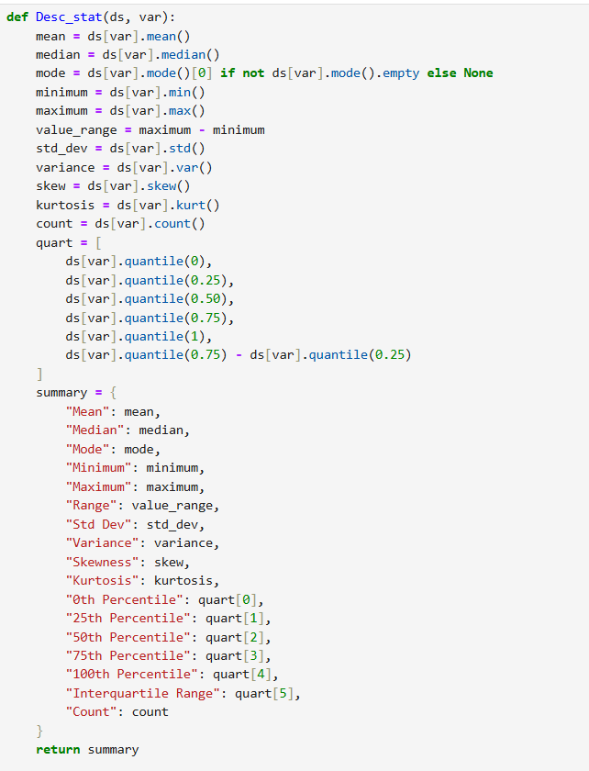

- Create a program to random sampling of size 150 and find the descriptive statistics for the dependent variable from the sample [Apply the descriptive function which you created].
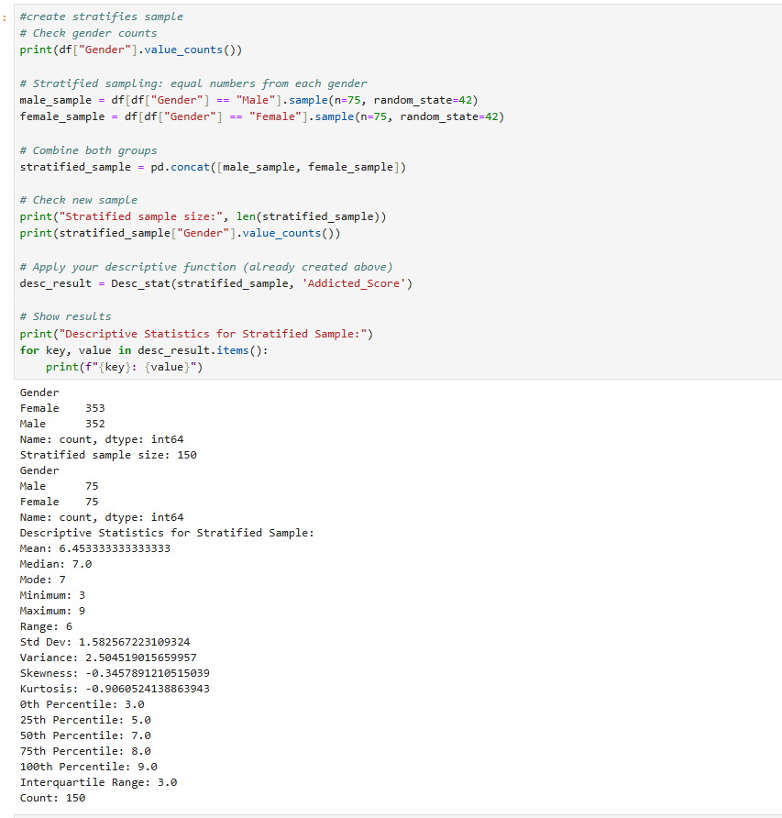

- Create a script for systematic sampling by giving certain conditions and finding the desc stat for the dependent variable from the sample [Apply the descriptive function which you created].
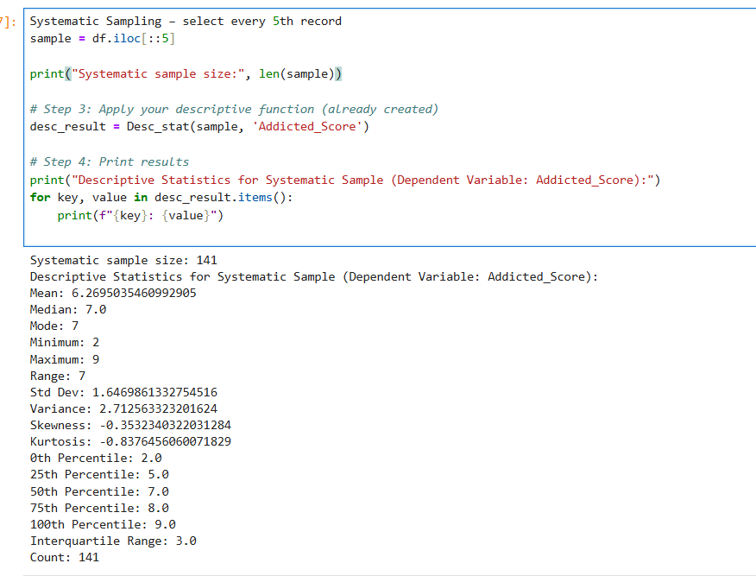

- Create a detailed descriptive statistics report about the dependent variable of the chosen dataset.
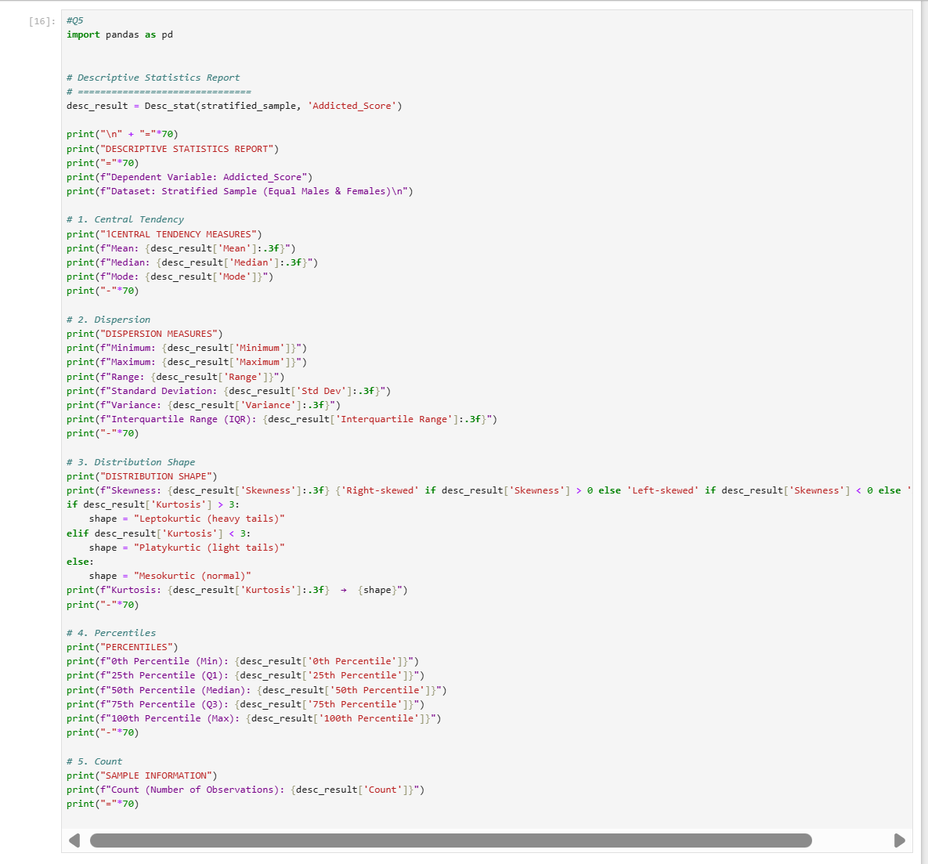

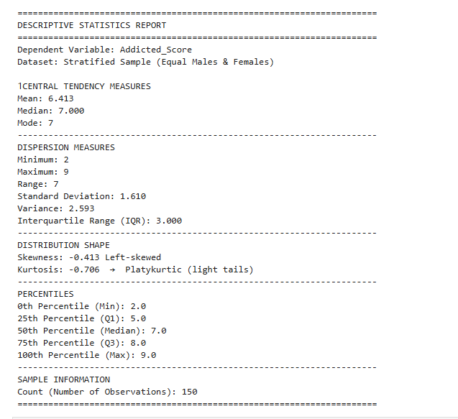

6.Visualize the dependent variable by the Graph/Chart of the following using Python Program:
a. Scatter plot
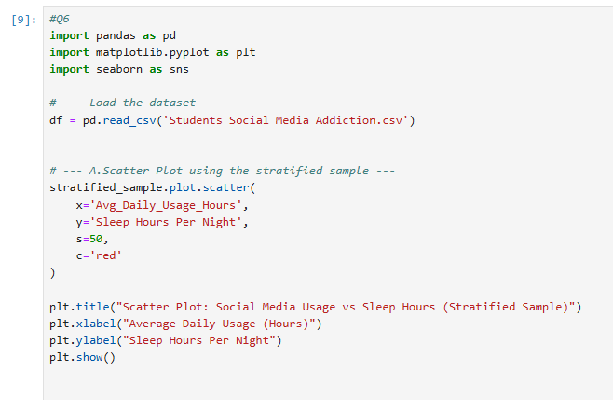
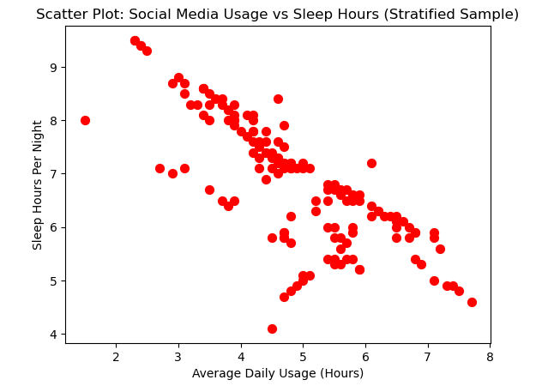

b. Box Plot

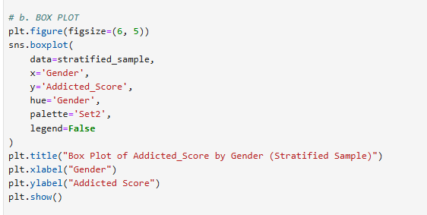

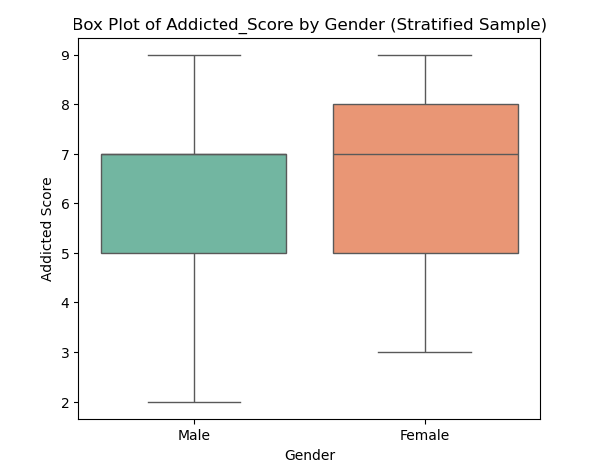

c. Histogram
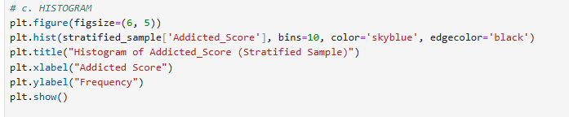

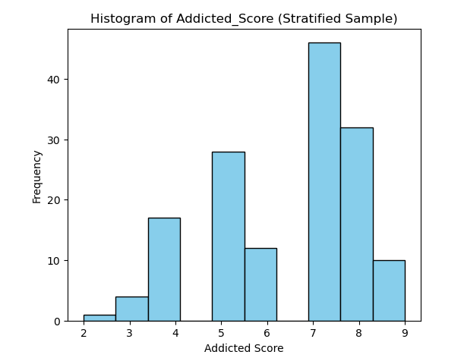

d. Heat Map
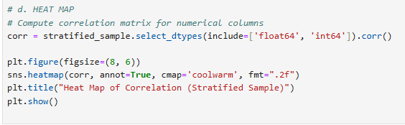

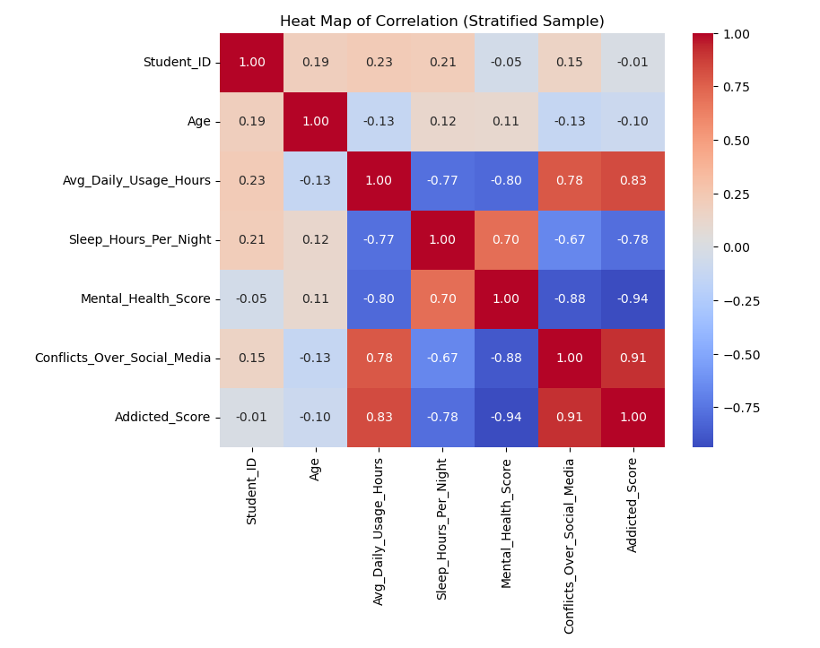

7. Perform the hypothesis test to find the correlation (Pearson and Spearman for numerical variable and chi-square test for categorical variable) between the independent variable and the dependent variable.
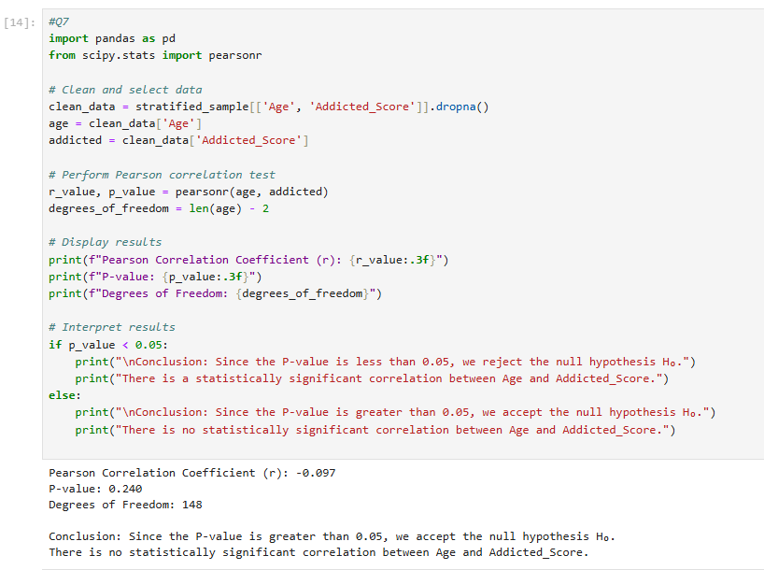
Note: If you have more than one independent variable, then choose any one of the independent variables.

8. Assess the performance of the dependent variable to know whether the sample is representative of the normal population by a one-sample t-test.
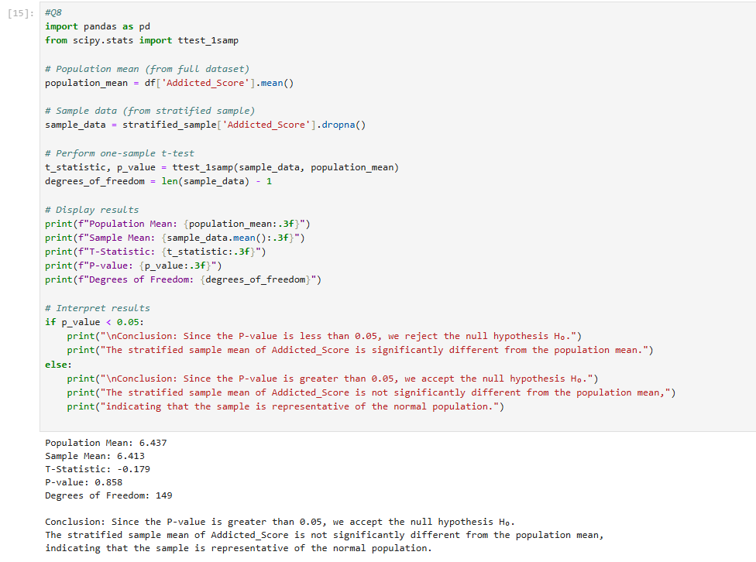

9. Simple Regression
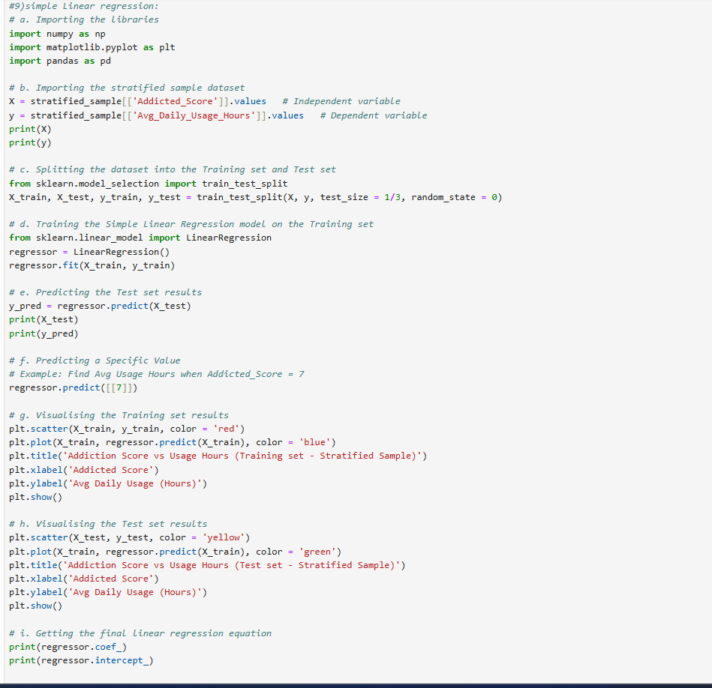

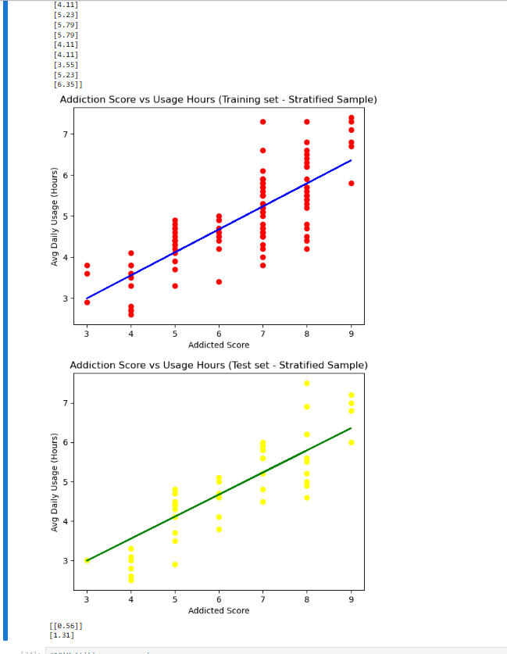

10. Multiple linear Regression
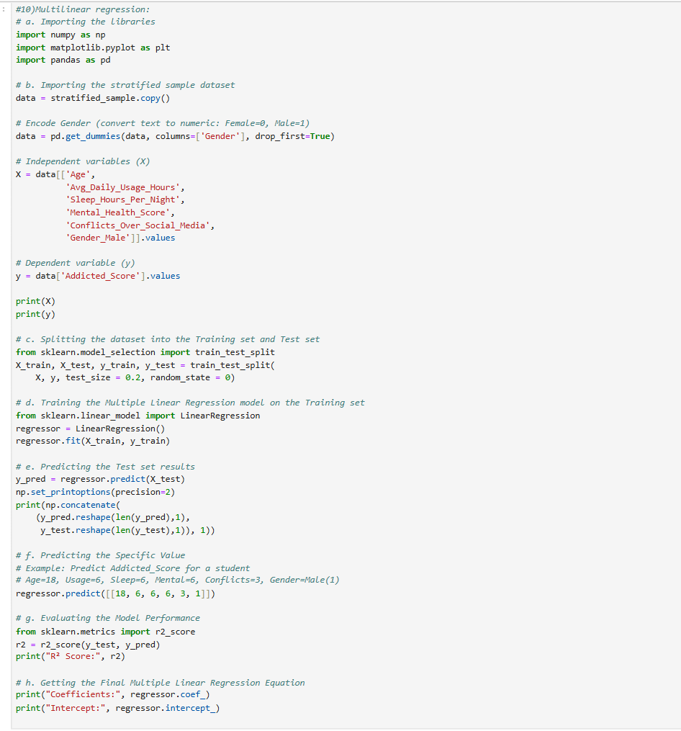

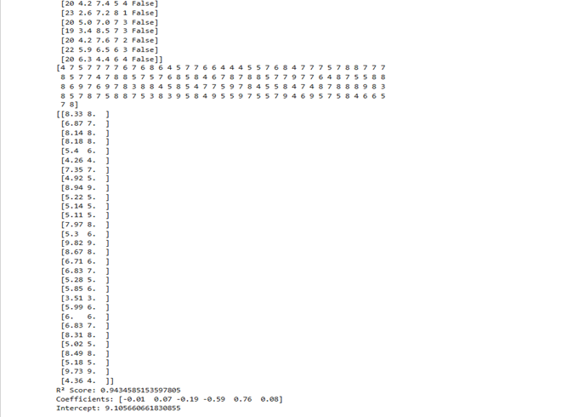
11. Predict the value of the dependent variable from the different classifier such as
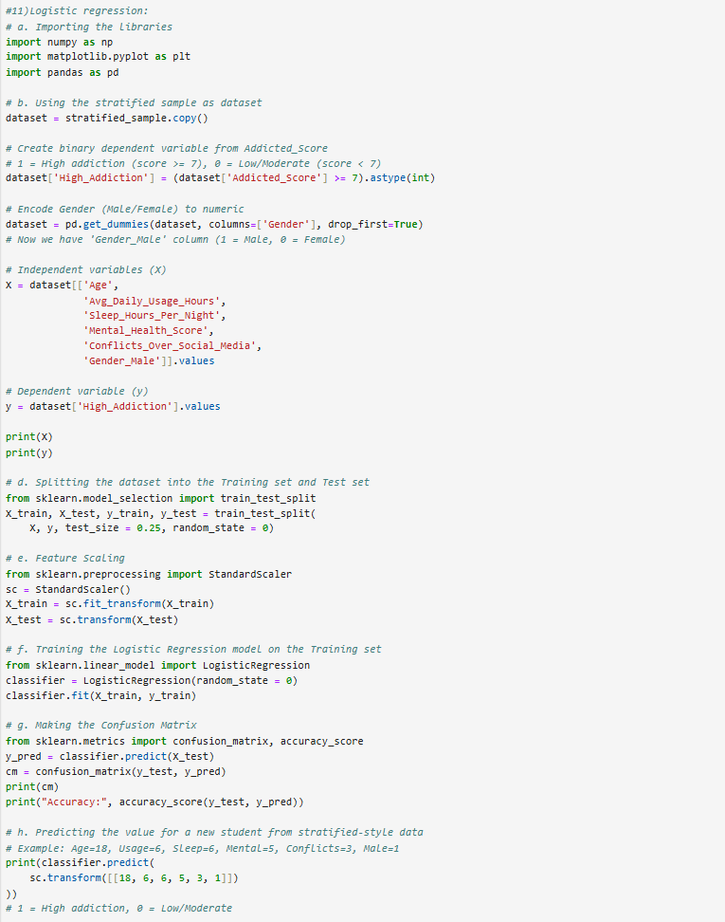
Logistic Regression

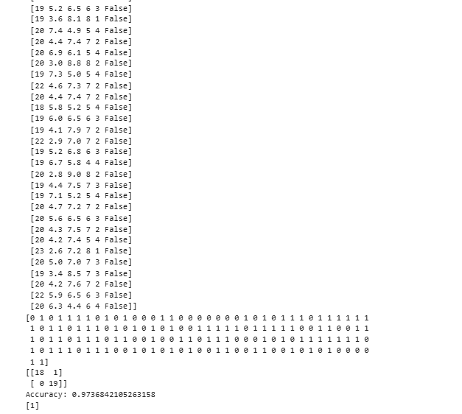

KNN
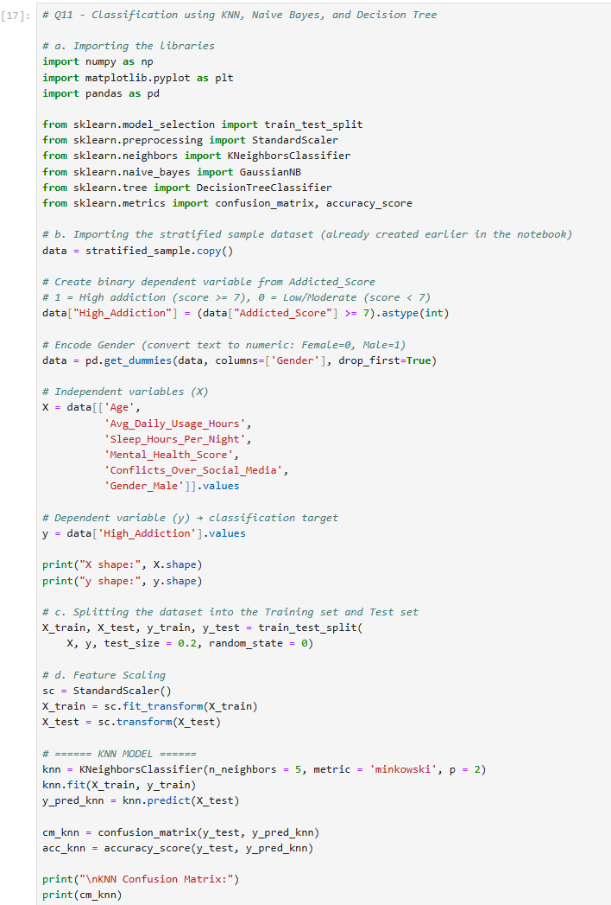
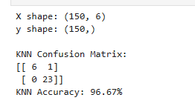

Naïve-Bayes
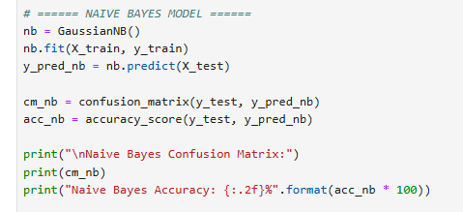
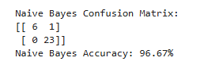
Decision Tree.
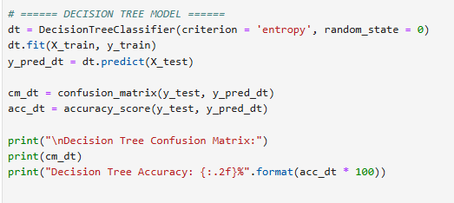
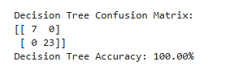

12.Evaluate the performance of each model using confusion matrix and accuracy and identify the best fit classifier for the chosen dataset.
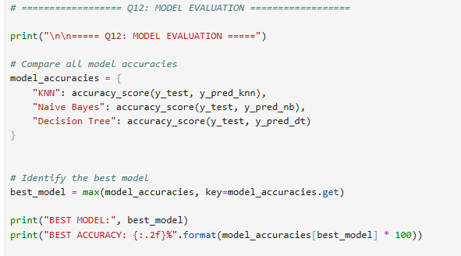
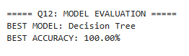
13. Predict the dependent variable by using best-fit classifier.
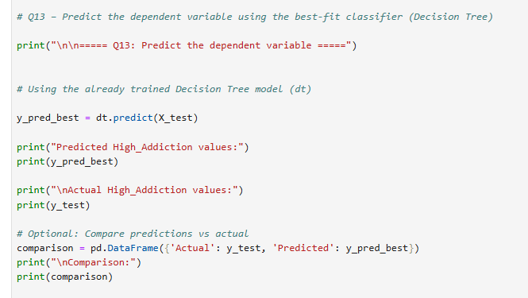
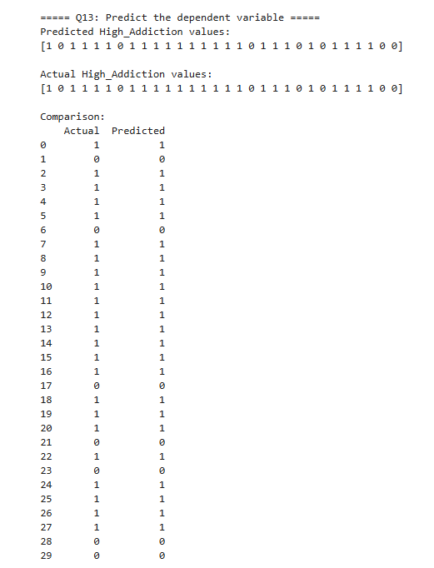
14. Perform the cluster analysis such as K-means and Horizontal for any field from the chosen dataset.
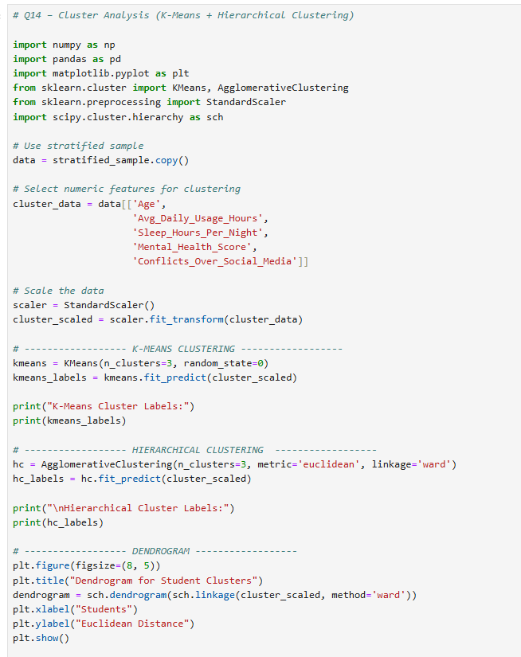
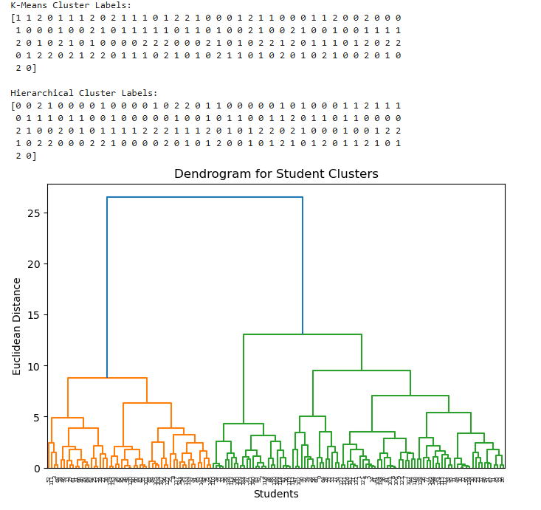
15. Explain the strategy for improving the system after viewing the cluster diagram.
- After performing clustering, it becomes clear that students naturally group together based on similarities in age, daily social media usage, sleep patterns, mental health scores, and conflicts caused by social media. The identified clusters demonstrate different behavioral patterns and risk levels.
- Cluster 1 consists of students who show high daily usage of social media, low sleep duration, low mental health scores, and a high number of conflicts. These characteristics indicate a high risk of social media addiction.
- Cluster 2 generally includes students with moderate usage hours, normal sleep duration, and average mental health scores. These students fall in the medium-risk category.
- Cluster 3 represents students with low usage hours, good sleep patterns, and high mental health scores. These students are considered low risk.
- Based on the insights gained from the clustering analysis, several strategies can be implemented to improve the system:
- Develop targeted awareness programs for high-risk students to promote healthier digital habits and better time management.
- Provide mental health support services, including counseling or stress-management programs, for students with low mental health scores.
- Encourage improved sleep habits through educational campaigns, reminders, and wellness activities.
- Offer optional screen-time monitoring tools for students with high usage patterns to help them track and reduce their social media consumption.
- Implement personalized intervention plans for each risk level. High-risk students may require intensive support, medium-risk students can benefit from balanced guidance, and low-risk students may simply need general awareness.
- Monitor academic performance more closely for students with higher conflict levels, since social media overuse may impact their academic outcomes.

LinkedIn Certificate Report
This section is dedicated to the submission of individual certificates for each course completed under the 'Anaconda Python for Data Science Professional Certificate' path on LinkedIn Learning. Students must ensure that all certificates are clearly labeled and arranged in the order of course completion.
Please include the following in this section:
1. Screenshot of course completion: 'Introduction to Data Science'
2. Screenshot of course completion: 'Statistics Foundations 1: The Basics'
3. Screenshot of course completion: 'Statistics Foundations 3: Using Data Sets'
4. Screenshot of course completion: 'Learning Python (2021)'
5. Screenshot of course completion: 'Python Data Analysis (2020)'
6. Final 'Anaconda Python for Data Science Professional Certificate' from LinkedIn Learning
7. Individual reflections on the learning experience (optional)
Project Oral (50%)
- Oral Communication: Each student will be assessed in the form of individual oral defense with PowerPoint presentation. [All CLOs] [10 Marks]
- Follow-up Questions and Discussion [All CLOs] [20 Marks]
- [Collaboration] [10 Marks].
- Anaconda Python for Data Science Professional Certificate (via Linkedin Learning submitted individually), individual reflection & Viva Question from certification [10 Marks].

Note: For oral presentations, a slide should be dedicated for each student to present their collaboration and lesson learnt. This will allow each student to showcase their individual contributions and reflect on the overall group experience. It also provides a structured format for sharing key takeaways and insights gained from working together.

Points 1 to 4 are a part of group grading [50%] and points 5,6, 7 and 9 contribute to individual grading.

Rubric
Please note that the Project rubric should reflect the project description and be CAP-compliant. Please feel free to customize the descriptors as per the project requirements and course level.

Group Project Rubric [Task-specific RUBRIC]

 |  | Absent (F) | Insufficient (1-59%)  (F) | Emerging (60-69%)  (D/D+/C-) | Satisfactory (70-76%)  (C/C+) | Competent (77-86%)  (B-/B/B+) | Mastering (87-100%)  (A-/A)
- Group Grading-Critical Thinking: Analysis and Evaluation [45%] | Deliverable 1: understanding of data analytics [CLO1]  (5%) |  | None of the following:  - Purpose of data analysis not mentioned.  - Selection of programming language is not referenced.  - Type of machine learning algorithm to be analyzed is not defined  - Variables for data analysis are not mentioned  . | Some but not all the following:  - Purpose of data analysis mentioned but not clear.  - Selection of programming language is referenced.  - Required machine learning algorithm to be analyzed is ill-defined [Too many models mentioned]  - Variables for data analysis are mentioned without justification | Most but not all the following:  - Purpose of data analysis is clearly mentioned.  - Selection of programming language is referenced.  - Required machine learning algorithm to be analyzed is defined, but without justification.  - Variables for data analysis are mentioned with justification but not clear | All of the following:  - Purpose of data analysis is clearly mentioned.  - Sound rationale for choosing the programming language  - Required machine learning algorithm to be analyzed is well-defined with appropriate justification.  - Variables for data analysis are mentioned with clear justification | All of the following:  - Purpose of data analysis is clearly mentioned with appropriate explanation  - Thoroughness of programming language chosen is evident.  - Student synthesizes information about machine learning algorithm from multiple disciplines and sources and presents them with clarity.  - Variables for data analysis are precisely defined with appropriate justification  - Employ outstanding knowledge about the data analysis from different sources
 | Deliverable 2: Apply data analysis and visualization techniques [CLO2]  (25%) |  | - No evidence of justification to perform descriptive statistics  - Function is not created for descriptive statistics  - Sampling techniques are not designed  - Exploratory analysis are not performed  - Hypothesis tastings are not achieved  - Data preprocessing is not devised  - Regression models are not functioned  - Optimization for regression model is not operated  - Best fit model is not enacted | Some but not all the following:  - Evidence of justification to perform descriptive statistics exist but not clear  - Function is created for descriptive statistics having major syntactical errors.  - Sampling techniques are designed but not appropriate  - Exploratory analysis are performed but ill-designed  - Hypothesis tastings are achieved with flaw  - Evidence for data preprocessing exist but with inappropriate techniques  - Regression models are functioned with huge faults  - Optimization for regression model is operated with inaccuracies  Best fit model is enacted without justification. | Most but not all the following:  - Evidence of justification to perform descriptive statistics exist with clear elucidation  - Function is created for descriptive statistics without flaws.  - Sampling techniques are designed with appropriate rationalization  - Exploratory analysis are performed with appropriate legends  - Hypothesis tastings are achieved appropriate assumption  - Evidence for data preprocessing exist but with applicable techniques  - Regression models are functioned without mistake  - Optimization for regression model is operated with appropriate metrics  - Best fit model is enacted appropriate interpretation | All of the following:  - Appropriate description and exploratory analysis provided.  - Sound rationale for chosen hypothesis testing  - High accuracy obtained for regression model  - Rigor is evident. | All of the following:  - Appropriate description and exploratory analysis provided along with exemplary analysis  - Sound rationale for chosen hypothesis testing and infer statically in commendable way  - Other regression model are handled obtained from different sources  - Rigor is evident.
 | Deliverable 3: The data model created using classification and clustering algorithm of machine learning [CLO2, CLO3]  (15%) |  | - Incomplete classification models are presented.  - No optimization and recommendation are performed for classification model.  - No evidence of any cluster analysis  - No strategies are produced from cluster model. | Some but not all the following:  - Comprehensive classification models are presented but with significant errors  - Thorough optimization and recommendation are performed for classification model but with poor validation  - Evidence of cluster analysis exists with poor performance  - Strategies are derived from cluster model which are insignificant | Most but not all the following:  - Comprehensive flawless classification models are presented  - Thorough optimization and recommendation are performed with appropriate validation for classification model  - Evidence of cluster analysis exists with better performance  - Strategies are derived from cluster model which are significant but not consistent | All of the following:  - Implemented all classification models  - Major validation works demonstrated on optimization and recommendation of classification model  - Appropriate cluster analysis was performed and good strategies are postulated and well-documented. | All of the following:  - All classification models are accurate  - Perform more classification models from different sources  - All cluster models are accurate  - Perform more cluster models from different sources  - Appropriate interpretation and recommendations are provided
 | Deliverable 4: Data Versioning  [CLO 4]  (5%) |  | - No evidence of creating a new repository and uploading project files to Git Hub  - Git is not configured with Git Hub  - No evidence for cloning Git hub repo to Git  - Push and Pull are not performed | Some but not all the following:  - Repository model is created but files are not uploaded to repo  - Git is not configured with Git Hub  - Evidence of cloning exists with appropriate options  - Push and Pull are performed which are insignificant | Most but not all the following:  - Repo are created and project files are uploaded to repo  - Git configuration are performed with accordance of Git Hub  - Evidence of cloning exists with proper options  - Push and Pull are significant but not consistent | All of the following:  - Repo are created and project files are uploaded  - Advanced configuration is performed on Git  - Many functions related to cloning is performed apart from basic operations  - Push and pull with different scenario are mentioned | All of the following:  - Scenario is created and explained about significance of repo creation  - Advanced configuration is performed on Git  - Different cloning techniques should be elucidated.  - Push and pull with different scenario are mentioned  - Branching should be exhibited
Group Grading:  Report Quality [5%] |  |  | - Incomplete report with missing most of the deliverable components.  - Too many typographical errors. | Some but not all of the following:  - Complete report with required deliverables.  - Clear table of contents showing all required sections.  - Free from formatting and typographical errors. | Most but not all of the following:  - Complete report with all required format and deliverables.  - Some minor formatting and/or typographical errors.  - Table of contents presented with some missing information. | All of the following:  - Complete report with required format and deliverables.  - Clear table of contents showing all required sections.  - Some minor formatting and/or typographical errors. | All of the following:  - Complete report with required format and deliverables.  - Clear table of contents showing all required sections.  - Free from formatting and typographical errors.

Individual Oral Presentation

Student (1) Name: ____________________________ Student HCT ID:_______________

Assessment Component | Absent (F) | Insufficient (1–59%) | Emerging (60–69%) | Satisfactory (70–76%) | Competent (77–86%) | Mastering (87–100%)
Oral Communication (Presentation)(10 Marks) | No clarity in message; poor eye contact, body language and decorum; major language errors; tension and no recovery from mistakes. | Communicates with limited clarity and purpose; minimal audience awareness; frequent errors; tension visible. | Communicates fairly clearly; some audience engagement; minor mistakes, recovers slowly. | Communicates clearly with good purpose; moderate audience engagement; recovers from small errors. | Clear communication; confident delivery; rare errors; good audience interaction. | Strong communication and fluency; confident and natural presentation; engages audience fully.
Follow-up Questions & Discussion(10 Marks) | Cannot answer any questions; shows no understanding. | Answers few questions; very limited understanding. | Answers some questions; shows partial understanding. | Answers most questions with general understanding. | Answers all questions with sound understanding. | Answers all with thorough, in-depth understanding and insight.
Poster Presentation(10 Marks) | No poster or extremely poor quality; irrelevant or unclear content. | Incomplete poster; little relevance; unorganized or hard to follow. | Basic poster with some key elements; clarity and visual layout need improvement. | Clear layout with relevant content; minor flaws in clarity or design. | Well-structured, visually effective, and informative. | Professional-quality design; clear, concise, and highly informative.
LinkedIn Learning – Anaconda Certification(20 Marks)Part 1 – Certificate submission (12 marks)Part 2 – Individual reflection (8 marks) | No certificates or reflection submitted. | Incomplete or incorrect certificates; reflection lacks depth or appears copied. | Partial certificate submission; basic reflection with limited insight. | All certificates submitted; reflection shows moderate insight. | All certificates complete and well-presented; reflection is thoughtful and connects to project. | Full certificate set with professional presentation; reflection is deep, personal, and highly relevant.

 | Absent | 1-59.49% | 59.5% - 69.49% | 69.5% - 76.49% | 76.5% à86.49% | 86.5% à100%
Collaboration (10%) |  | - Does not partake in the task or is so frequently distracted that he/she produces.  - Having made no contribution to the group's objective. | - Participates in the task but does not collaborate with others or contribute to the group process.  - Participates in discussions.  - Expresses own opinion and viewpoints.  - Remains dedicated to the subject.  - Performs independently specific tasks | - Cooperates with the group process, but does not coordinate contributions with those of others.  - Does not interrupt while listening.  - Actively seeks the input of others.  - Accepts duties that have been assigned.  - Complies with the group consensus.  - Utilizes the ideas of others | - Coordinates processes and products with those of teammates, but does not resolve significant conflicts.  - Actively pays attention to what is being said.  - Offers and accepts constructive feedback.  - Adapts ideas and/or processes to the needs of colleagues.  - Seeks consensus.  - Effectively resolves trivial disputes | - Student coordinates collaborative processes and outputs.  - Effectively resolves both significant and minor conflicts.  - Expresses disagreements in an open and diplomatic manner.  - Supports group decisions even if they are not unanimously supported.  - Compromised and negotiated to attain an agreement
Oral Communication (Presentation)  (10 Marks) [All CLOs] |  | - Communicates with a limited sense of audience and purpose  - No eye contact, no body language, and no decorum  - Communicates with limited clarity  - Uses language with limited accuracy and effectiveness.  - Tension and anxiety are palpable;  - Has difficulty recovering from errors. | Not all of the foregoing are true:  - Communicates with a clear sense of audience and purpose  - Eye contact, body language, and decorum)  - Communicates information and ideas with considerable clarity  - Uses language with considerable accuracy and efficacy  - Makes insignificant errors, but rapidly recovers  - Displays minimal or no tension. | Most of the following, but not all:  - Communicates with a clear sense of audience and purpose  - Eye contact, body language, and decorum)  - Communicates information and ideas with substantial clarity  - Uses language with substantial accuracy and effectiveness.  - Makes simple mistakes but recovers swiftly;  - Displays minimal or no tension. | Each of the subsequent:  - Communicates with a clear sense of audience and purpose  - Eye contact, body language, and decorum  - Communicates information and ideas with considerable clarity  - Uses language with considerable accuracy and efficacy.  - Makes insignificant errors, but recovers rapidly  - Demonstrates minimal or no tension. | Each of the subsequent:  - Communicates with a strong awareness of audience and purpose  - Maintains audience's attention by using direct eye contact and rarely glancing at notes.  - Communicates information and ideas with a high degree of precision and precision  - Student appears at ease and confident, with no errors.
Follow-up questions and discussion (20 Marks) [All CLOs] |  | Unable to answer questions from the examining board | Able to answer some but not all questions from the examining board | Able to answer most but not all questions from the examining board | Capable of answering all of the examining board's queries. | Capable of responding to all inquiries and demonstrating a thorough understanding of the material.
Part 1 – Certificate submission (6marks)  Part 2 – Poster presentation (4 marks) |  | Only one course was submitted | Only two courses were submitted | Only three courses were submitted | Only four courses were submitted | Final Certificate and all course certificates submitted
 |  | Major inaccuracies; key concepts missing or misunderstood. | Some inaccuracies; limited explanation of algorithm or results. | Mostly accurate; covers main aspects (algorithm, dataset, results) but lacks depth. | Accurate and clear; demonstrates good understanding with minor omissions. | Comprehensive, accurate, and insightful; demonstrates mastery with critical analysis.

Appendix:
Individual Reflection:

1. Overview of Certification Experience
- Briefly describe your experience completing the Anaconda Python for Data Science Professional Certificate.
- What motivated you to complete the certification?
- How did you manage your learning schedule?

2. Reflection on CLO1 – Understanding Data Analytics Principles
CLO1: Demonstrate an understanding of data analytics principles to solve business problems
- Which modules helped you understand the basic principles of data analytics?
- How did these concepts support your approach in the main project?
- Give an example of how a principle from the certification influenced your problem-solving in the project.

3. Reflection on CLO2 – Visualization and Decision-Making
CLO2: Apply data analysis and visualization techniques to support data-driven decision-making
- Which visualization or analysis techniques from the certification were new or improved for you?
- How did you apply these techniques in your project?
- Describe a decision or insight in the project that was influenced by your visual analysis skills.

4. Reflection on CLO3 – Programming and ML Techniques
CLO3: Create scripts to solve business problems using data analysis techniques such as classification, clustering, optimization, and recommendation
- Which programming-related course in the certification helped you the most?
- Describe a script or model you created in your project and how certification content helped you build it.
- What challenges did you face while implementing ML models, and how did you overcome them?

5. Personal Takeaways and Future Use
- What was the most valuable learning or insight you gained?
- How has this certification prepared you for future data science work or job roles?
- What topics do you plan to explore further?

A sample reflection:
Completing the Anaconda Python for Data Science certification through LinkedIn Learning was a valuable journey. I appreciated the structured flow of the courses, which gradually built up from core concepts to advanced applications. I scheduled one module per week, which helped me manage it alongside project work.
Through the Intro to Data Science and Statistics Foundations modules, I strengthened my understanding of data analytics principles (CLO1). This helped me clearly define the problem in our project and justify the use of regression models to solve it.
The Python Data Analysis module enhanced my skills in data visualization and interpretation (CLO2). I applied scatter plots and heat maps in our analysis to support decisions, especially when identifying correlations and removing outliers.
The Learning Python and classification content supported my coding ability (CLO3). I wrote scripts to build logistic regression and decision tree classifiers confidently. These skills directly impacted my contributions to the modeling and evaluation parts of the project.
Overall, the certification helped me connect classroom learning with real-world tools and methods. I feel more confident now in applying data science techniques and plan to explore time series forecasting next.

